


A Summer Training Report

Submitted by

Naitik Shah
(12202130501081)

In partial fulfilment of the requirements for the
Degree of Bachelor of Technology
in
Computer Science and Design

Department of Computer Engineering
G H Patel College of Engineering & Technology
Vallabh Vidyanagar

The Charutar Vidya Mandal (CVM) University
Vallabh Vidyanagar

August 2025

CERTIFICATE

This is to certify that this work embodied in this report entitled, “Summer Training” was carried out by Mr. Naitik Shah (12202130501081) at G H Patel College of Engineering & Technology for partial fulfilment of degree of Bachelor of Technology in Computer Science & Design to be awarded by The Charutar Vidya Mandal University, Vallabh Vidyanagar. This work has been carried out under my supervision and is to the satisfaction of department.

Prof. Krushna Pandit  Assistant Professor,  CP Department, GCET | Dr. Sudhir Vegad  Professor and Head,  CP Department, GCET

Date: 16-7-2025
Place: Vallabh Vidyanagar



Date:20th Jun 2025

INTERNSHIP COMPLETION CERTIFICATE

This is to certify that Naitik Harsiddhbhai Shah a student of GCET College has successfully completed a 15-day internship at TatvaSoft from 26th May 2025 to 13th Jun 2025.

During the internship, Naitik Harsiddhbhai Shah worked on tasks related to .NET and Angular technologies and demonstrated sincere effort and learning.

We trust the skills gained during this internship bring you success in your professional journey.
Best wishes for future endeavours.

For TatvaSoft

Authorized Signatory Poorva Biswas HR Dept.
Email: hr@tatvasoft.com

Ground Floor, Tatva House, Behind Rajpath Club Road, Opp-Golf Academy, Bodakdev, Ahmedabad-380054, Gujarat, India. Website: www.tatvasoft.com,
E-mail: Info@tatvasoft.com; Phone: +91 9601421472.

Acknowledgement
The completion of any work depends upon cooperation, co-ordination, and combined efforts of several sources of knowledge.
I would like to express my deepest thanks to Prof. Harsh Mehta, my industry mentor for his valuable inputs, guidance, encouragement, and wholehearted cooperation throughout the duration of our internship.
I would like to express our sincere thanks Head of the Department, Dr. Sudhir Vegad and Principal, Dr. Kaushik Nath for providing a chance for such a wonderful internship opportunity from the institute.
I would like to thank Prof. Krushna Pandit, my Internal Guide for his support and advice to complete the internship.
We are gratified to all faculty members of Department of Computer Engineering, G H Patel College of Engineering and Technology, Vallabh Vidyanagar for their special attention and suggestions.

Mr. Naitik Shah (12202130501081)

Abstract
During my summer internship training in 2025, I participated in a 15-day intensive program focused on full-stack web development with a real-world project titled "Virtual Community Support System". The objective of the project was to design and implement a secure and scalable web platform that enables volunteers to explore, apply for, and manage social missions, while allowing administrators to manage mission listings, user roles, and application data.
The project was developed using a PostgreSQL database for backend data management, a .NET Web API for server-side logic and RESTful endpoint creation, and Angular for building a responsive and user-friendly frontend interface. Key features included user authentication, role-based authorization (Admin and User), CRUD operations for users and missions, mission application workflows, sorting, filtering, pagination, and profile management.
Security was handled using JWT-based token authentication, while modular code structure and the Entity Framework Code First approach ensured maintainability and future scalability. The system was tested using Swagger and deployed locally, with an introduction to AWS cloud deployment for production readiness.
This project demonstrates the application of modern web technologies to build a meaningful digital platform that fosters community engagement, providing hands-on experience in backend logic, frontend design, and full-stack integration within a professional development workflow.

List of Figures
Figure 5.4 | Database Schema . . . . . . . . . . . . . . . . . . . . . . . . . . . . . . . . . . . . .. . | 24
Figure 6.6.1 | Swagger Backend .. . . . . . . . . . . . . . . . . . . . . . . . . . . . . . . . . . . . . | 28
Figure 6.6.2 | Frontend. . . . . . . . . . . . . . . . . . . . . . . . . . . . . . . . . . . . . . . . . . . . . . | 28

List of Tables
Table 1.2.2 | Limitations of Monolithic or Static platforms. . . . . . . . . . . . . . . . . | 3
Table 1.4.1 | Scope and Application Context . . . . . . . . . . . . . . . . . . . . . . . . . . . | 5
Table 6.2 | Comparative Analysis. . . . . . . . . . . . . . . . . . . . . . . . . . . . . . . . . . . | 25

Table of Contents

Institute Certificate |  |  |  |  |  | ii
Company Certificate |  |  |  |  |  | iii
Acknowledgement |  |  |  |  |  | iv
Abstract |  |  |  |  |  | V
List of Figures |  |  |  |  |  | vi
List of Tables |  |  |  |  |  | vii
1. | Introduction . . . . . . . . . . . . . . . . . . . . . . . . . . . . . . . . . . . . . . . . . . . . . . . . . . . . . . . . |  |  |  |  | 01
 |  | 1.1 | Background & Motivation . . . . . . . . . . . . . . . . . . . . . . . . . . . . . . . . . . . . . . .  1.1.1 Importance of Community Support Platforms . . .. . . . . . . . . . .  1.1.2 Role of Full-Stack Development in Social Applications . . . . .  1.1.3 Challenges in Building Volunteer Management Systems |  |  | 0101  01  02
 |  | 1.2 | Problem Statement . . . . . . . . . . . . . . . . . . . . . . . . . . . . . . . . . . . . . . . . . . . . |  |  | 02
 |  |  |  | 1.2.1 | Need for Scalable Virtual Support Platforms . . . .. . . . . . . . . . . | 02
 |  |  |  | 1.2.2 | Limitation of Monolithic or Static Platforms. . . . . . . . . . . . . . . | 02
 |  | 1.3 | Objectives . . . . . . . . . . . . . . . . . . . . . . . . . . . . . . . . . . . . . . . . .. . . . . . . . . . .  1.3.1 Primary. . . . . . . . . . . . . . . . . . . . . . . . . . . . . . . . . . . . . . . . . . . .  1.3.2 Secondary . . . . . . . . . . . . . . . . . . . . . . . . . . . . . . . . . . . . . . . . . .  1.3.3 Tertiary. . . . . . . . . . . . . . . . . . . . . . . . . . . . . . . . . . . . . . . . . . . . |  |  | 04  04  04  04
 |  | 1.4 | Scope and Limitations . . . . . . . . . . . . . . . . . . . . . . . . . . . . . . . . . . . . . . . . . .  1.4.1 Scope and Application Context. . . . . . . . . . . . . . .. . . . . . . . . . .  1.4.2 Time Frame covered. . . . . . . . . . . . . . . . . . . . . . . . . . . . . . . . . .  1.4.3 Project Limitations. . . . . . . . . . . . . . . . . . . . . . . . . . . . . . . . . . . |  |  | 05  05  05  06
2. | Literature Review . . . . . . . . . . . . . . . . . . . . . . . . . . . . . . . . . . . . . . . . . . . . . . . . . . . |  |  |  |  | 07
 |  | 2.1 | Traditional Approaches to Community Platforms . . . . . . . . . . . . . . . . . . . . .  2.1.1 Static Web Portals. . . . . . . . . . . . . . . . . . . . . . . . . . . . . . . . . . . .  2.1.2 Manual Workflows and Paper-based Tracking. . . . . . . . . . . . . |  |  | 07  07  07
 |  | 2.2 | Modern Full-Stack Development Approaches . . . . . . . . . . . . . . . . . . . . . . . |  |  | 08
 |  |  |  | 2.2.1 | Role-Based Web Applications . . . . . . . . . . . . . . . . . . . . . . . . . . | 08
 |  |  |  | 2.2.2 | CRUD Architecture in Web Apps. . . . . . . . . . . . . . . . . . . . . . . . | 08
 |  | 2.3 Technologies Used in Virtual Community Platform . . . . . . . . . . . . . . . . . . . |  |  |  | 09
 |  |  |  | 2.3.1 | PostgreSQL for Relational Data Management . . . . . . . . . . . . . . | 09
 |  |  |  | 2.3.2 | .NET Web API for Backend Logic . . . . . . . . . . . . . . . . . . . . . . . | 09
 |  |  |  | 2.3.3 | Angular for Frontend Interaction . . . . . . . . . . . . . . . . . . . . . . . . | 09
3. | Methodology & Data Collection . . . . . . . . . . . . . . . . . . . . . . . . . . . . . . . . . . . . . . . .  3.1 Data Source and Collection. . . . . . . . . . . . . . . . . . . . . . . . . . . . . . . . . . . . . . . .  3.1.1 Application Data Model . . . . . . . . . . . . . . . . . . . . . . . . . . . . . . . .  3.1.2 Data Parameters. . . . . . . . . . . . . . . . . . . . . . . . . . . . . . . . . . . . . . .  3.1.3 Data Quality Assessment. . . . . . . . . . . . . . . . . . . . . . . . . . . . . . . .  3.2 Data Preprocessing. . . . . . . . . . . . . . . . . . . . . . . . . . . . .. . . . . . . . . . . . . . . . . .  3.2.1 Missing Value Handling. . . . . . . . . . . . . . .. . . . . . . . . . . . . . . . . .  3.2.2 Data Normalization. . . . . . . . . . . . . . . . . . . . . . . . . . . . . . . . . . . .  3.3 Exploratory Data Analysis. . . . . . . . . . . . . . . . . . . . . .. . . . . . . . . . . . . . . . . . .  3.3.1 Statistical Summary. . . . . . . . . . . . . . . . . . . . . . . . . . . . . . . . . . . .  3.3.2 Trend Analysis. . . . . . . . . . . . . . . . . . . . . . . . . . . . . . . . . . . . . . . .  3.3.3 Seasonality Detection. . . . . . . . . . . . . . . . . . . . . . . . . . . . . . . . . . .  3.3.4 Correlation Analysis. . . . . . . . . . . . . . . . . . . . . . . . . . . . . . . . . . |  |  |  |  | 11  11  11  11  12  13  13  13  14  14  14  15  15
4. | Time Series Analysis. . . . . . . . . . . . . . . . . . . . . . . . . . . . . . . . . . . . . . . . . . . . . . . . . .  4.1 Stationary Testing. . . . . . . . . . . . . . . . . . . . .. . . . . . . . . . . . . . . . . . . . . . . . . .  4.1.1 Checks and Validations. . . . . . . . . . . . . . . . . . . . . . . . . . . . . . . . .  4.1.2 Data Transformation Techniques.. . . . . . . . . . . . . . . . . . . . . . . . .  4.1.3 Differencing Operations. . . . . . . . . . . . . . . . . . . . . . . . . . . . . . . . .  4.2 Seasonal Decomposition. . . . . . . . . . . . . . . . . . . . . . . . . . . . . . . . . . . . . . . . .  4.2.1 Trend Component Analysis. . . . . . . . . . . . . . . . . . . . . . . . . . . . . .  4.2.2 Seasonal Pattern. . . . . . . . . . . . . . . . . . . . . . . . . . . . . . . . . . . . . . .  4.2.3 Residual Analysis. . . . . . . . . . . . . . . . . . . . . . . . . . . . . . . . . . . . . .  4.3 Event Dependencies and temporal Workflows . . . . . . . . . . . . . . . . . . . . . . .  4.3.1 Application Workflows. . . . . . . . . . . . . . . . . . . . . . . . . . . . . . . . .  4.3.2 Parameters Tuning and testing. . . . . . . . . . . . . . . . . . . . . . . . . . . |  |  |  |  | 16  16  16  17  17  17  18  18  19  19  19  20
 | 5. Web Application Development. . . . . . . . . . . . . . . . . . . . . . . . . . . . . . . . . . . . . . .  5.1 System Architecture. . . . . . . . . . . . . . . . . . . . . . . . . . . . . . . . . . . . . . . . . . . .  5.2 User Interface Design. . . . . . . . . . . . . . . . . . . . . . . . . . . . . . . . . . . . . . . . . .  5.3 Model Integration. . . . . . . . . . . . . . . . . . . . . . . . . . . . . . . . . . . . . . . . . . . . . .  5.4 Database Schema . . . . . . . . . . . . . . . .. . . . . . . . . . . . . . . . . . . . . . . . . . . . . .  6. Result & Analysis. . . . . . . . . . . . . . . . . . . . . . . . . . . . . . . . . . . . . . . . . . . . . . . . . .  6.1 Functional Evaluation. . . . . . . . . . . . . . . . . . . . . . . . . . . . . . . . . . . . . . . . . .  6.2 Comparative Analysis. . . . . . . . . . . . . . . . . . . . . . . . . . . . . . . . . . . . . . . . . .  6.3 System Performance Observations. . . . . . . . . . . . . . . . . . . . . . . . . . . . . . . .  6.4 Limitations and Areas for Improvement. . . . . . . . . . . . . . . . . . . . . . . . . . . .  6.5 Real-World Relevance. . . . . . . . . . . . . . . . . . . . . . . . . . . . . . . . . . . . . . . . . .  6.6 Screenshots . . . . . . . . . . . . . . . . . . . . . . . .. . . . . . . . . . . . . . . . . . . . . . . . . . .  6.6.1 Swagger Backend. . . . . . . . . . . . . . . . . . . . . . . . . . . . . . . . . . . . . . . . .  6.6.2 Frontend. . . . . . . . . . . . . . . . . . . . . . . . . . . . . . . . . . . . . . . . . . . . . . . .  7. Conclusion & Future Work. . . . . . . . . . . . . . . . . . . . . . . . . . . . . . . . . . . . . . . . . .  7.1 Summary of Achievements. . . . . . . . . . . . . . . . . . . . . . . . . . . . . . . . . . . . . .  7.2 Future Enhancements. . . . . . . . . . . . . . . .. . . . . . . . . . . . . . . . . . . . . . . . . . .  7.3 Technical Contributions. . . . . . . . . . . . . .. . . . . . . . . . . . . . . . . . . . . . . . . . . |  |  |  |  | 21  21  22  23  24  25  25  25  26  27  27  28  28  28  29  29  30  31

Chapter 1: Introduction

1.1 Background & Motivation

1.1.1 Importance of Community Support Platforms
In today's digital-first world, the need for accessible, organized, and role-driven community platforms has grown rapidly. Whether in response to social causes, volunteering missions, or local initiatives, digital tools can amplify collaboration, streamline mission tracking, and increase user engagement.
A well-designed virtual community support platform can:
- Enhance Participation: Allow volunteers to easily discover, apply for, and manage missions relevant to their interests.
- Promote Accountability: Enable administrators to monitor and manage users, missions, and participation records efficiently.
- Encourage Transparency: Ensure access control and data integrity through secure user roles and authorization flows.
- Bridge Technical Gaps: Provide user-friendly, scalable, and deployable solutions for mission-driven organizations.
The core idea behind this project is to create a robust and modular full-stack system where users (volunteers) and administrators can collaboratively manage and participate in community support missions.

1.1.2 Role of Full-Stack Development in Social Applications
Unlike traditional static websites, modern full-stack applications can dynamically handle:
- User Role Management: Assigning and enforcing user permissions (e.g., Admin vs. User).
- Data-Driven Interfaces: Presenting personalized views (e.g., “My Profile,” “My Missions”) using real-time database queries.
- Secure Operations: Ensuring data safety and access control with authentication and authorization.
- CRUD Automation: Empowering users to interact directly with data (missions, themes, skills) through intuitive interfaces.
This project leverages a powerful tech stack—PostgreSQL, .NET Web API, and Angular—to build a responsive and scalable platform that reflects the core needs of community mission management.

1.1.3 Challenges in Building Volunteer Management Systems
While there are several platforms in the social sector, most suffer from one or more of the following issues:
- Rigid role management or absence of fine-grained access control.
- Lack of real-time interactivity and dynamic data handling.
- Manual backend processes for mission assignments and approval workflows.
- Poor UI/UX for mission navigation, filtering, and application.
- Complex or unclear deployment procedures for practical use.
This internship project directly addresses these gaps by implementing clean architecture, role-based access, and deployment-ready code for real-world application.

1.2 Problem Statement

1.2.1 Need for Scalable Virtual Support Platforms
Community support platforms must be able to:
- Serve both admin and user roles without exposing unintended access.
- Support CRUD operations across mission-related entities like Theme, Skill, and Application.
- Be scalable for future extensions like volunteer reviews, mission progress tracking, or chat functionality.
- Be deployable to the cloud (e.g., AWS) for real-world usability.
Despite available tools and frameworks, beginner developers often struggle to integrate frontend-backend-database layers with robust security and modularity. This project bridges that learning curve using a structured 15-day plan.

1.2.2 Limitations of Monolithic or Static Platforms
Aspect | Traditional Platforms | Our Full-Stack Solution
User Management | Hardcoded access or static pages | Dynamic role-based access control
Mission Handling | Manual or spreadsheet-based | Fully CRUD-enabled mission lifecycle
UI/UX Experience | Outdated forms and no interactivity | Reactive Angular frontend with filters
Security | Minimal login validation | Token-based AuthN/AuthZ with roles
Scalability | Difficult to extend or maintain | Modular and API-driven architecture
Deployment | Localhost only or manual transfers | Configured for AWS cloud deployment

1.3 Objectives

1.3.1 Primary: Build Role-Based Community Platform
The core goal is to develop a secure, functional, and intuitive Virtual Community Support platform with two user roles:
- Admin: Can manage missions, themes, skills, and users.
- User (Volunteer): Can view and apply to missions, edit profiles.
This platform was built from scratch using:
- PostgreSQL for the database layer.
- .NET Web API for business logic and REST endpoints.
- Angular for a rich, reactive frontend.

1.3.2 Secondary: Implement Full CRUD + Filters + Pagination
CRUD operations were developed for:
- Mission
- Theme
- Skill
- User
- Mission Applications
Advanced features like filtering, sorting, and paging were also implemented for enhanced usability and performance.

1.3.3 Tertiary: Enable Deployment and Usability
The final objective was to:
- Build a responsive "My Profile" page for users.
- Configure and deploy the full project on AWS, making it production-ready.
- Ensure the system is modular enough for future integration (e.g., notifications, analytics).

1.4 Scope and Limitations

1.4.1 Scope and Application Context
This project focuses on virtual missions for community support, such as volunteering, event organizing, or awareness campaigns.
Module | Entities Involved | Purpose
User Management | Admin, Volunteer | Authentication and Role-based access
Missions | Title, Description, Theme | CRUD operations for mission listing
Skills | Skill name, Assigned Mission | Helps match users to relevant missions
Themes | Mission category | For filtering and mission organization
Applications | User ↔ Mission | Apply, retrieve, and manage application records

1.4.2 Time Frame Covered
This project was implemented in 15 days with structured daily goals:
- Days 1–3: Setup PostgreSQL, Angular, and .NET Web API foundation.
- Days 4–10: Authentication, Role-based Access, and CRUD implementation.
- Days 11–13: Mission Apply flow, profile page, and deployment.
- Days 14–15: Review, polish, and AWS configuration.

1.4.3 Project Limitations
- UI Complexity: Limited time meant avoiding advanced UI elements like drag-drop or calendars.
- No Chat or Notifications: The system doesn’t include real-time messaging or email alerts.
- Limited Analytics: No dashboards or metrics tracking for now.
- Static Data Source: Missions and applications are inserted manually (no external APIs).
Future versions could enhance the platform with gamification, mission progress tracking, chat, and mobile responsiveness.

Chapter 2: Literature Review

2.1 Traditional Approaches to Community Platforms

2.1.1 Static Web Portals
Earlier community platforms relied heavily on static websites—simple HTML/CSS pages or CMS systems with little to no interactivity. While they served the purpose of information dissemination, they lacked user-level interactivity or backend logic for handling dynamic tasks like user registration, mission management, or application tracking.
Limitations of static systems include:
- No real-time updates or interactivity
- Manual content management
- No access control or role differentiation
- Poor scalability and performance for growing communities

2.1.2 Manual Workflows and Paper-based Tracking
Before digitization, community support tasks like volunteer assignment, mission progress, or attendance were often managed through spreadsheets or paperwork. This method lacked transparency, was error-prone, and didn’t scale.
Key drawbacks:
- Limited traceability
- Data silos and fragmentation
- Zero user personalization
- No live communication between users and organizers
These traditional methods fail to meet the demands of modern communities that need efficient user role management, digital collaboration, and automated workflows.

2.2 Modern Full-Stack Development Approaches

2.2.1 Role-Based Web Applications
Role-based access control (RBAC) is a standard security practice in modern web applications. It restricts system access based on users’ roles, preventing unauthorized access to sensitive data or functionalities.
RBAC Benefits in Community Platforms:
- Isolates admin operations (CRUD on missions, themes, users) from volunteer tasks (view/apply)
- Reduces security risks by minimizing data exposure
- Allows scalable permission management
- Enables personalized user experiences
Numerous studies and implementations have validated RBAC as a core architectural principle in scalable, secure systems (Sandhu et al., 1996).

2.2.2 CRUD Architecture in Web Apps
Create-Read-Update-Delete (CRUD) operations are the backbone of all data-driven systems. In community support platforms, CRUD enables:
- Admins to manage missions, themes, skills, and users
- Users to register, apply to missions, and update their profile
The .NET Web API framework follows REST principles to enable seamless CRUD operations, while Angular enables reactive forms and binding for real-time frontend interactivity.
Advantages of CRUD-centric architecture:
- Clear and maintainable backend structure
- Full lifecycle control of resources
- Easy frontend/backend integration
- Flexible for future enhancements (e.g., reviews, ratings)

2.3 Technologies Used in Virtual Community Platforms

2.3.1 PostgreSQL for Relational Data Management
PostgreSQL is an open-source, enterprise-class relational database system known for its stability and extensibility. It supports advanced data types, strong ACID compliance, and powerful querying with SQL and subqueries.
Features that benefit this project:
- Relational integrity for mission-user relationships
- Joins and subqueries for mission filtering and skill mapping
- Efficient data retrieval for search and pagination
- Schema flexibility for future expansion
According to Stonebraker et al. (2005), PostgreSQL has become a go-to RDBMS for robust data modelling in full-stack applications.

2.3.2 .NET Web API for Backend Logic
.NET Core Web API allows the development of RESTful services that can handle HTTP requests for data access. It follows a layered architecture using the Repository pattern and Entity Framework (EF) for database interaction.
Notable features in this project:
- Clean separation of concerns via Controllers, Services, and Repositories
- EF Code First approach for faster model-to-database binding
- Use of LINQ for expressive and optimized data queries
- Integration of JWT for secure authentication/authorization
Microsoft’s .NET stack is widely adopted in enterprise-level projects due to its maintainability and rich ecosystem.

2.3.3 Angular for Frontend Interaction
Angular, developed by Google, is a powerful framework for building dynamic and modular single-page applications (SPAs). It provides two-way data binding, dependency injection, and powerful form handling capabilities.
Angular’s role in this project:
- Reactive forms for login and mission applications
- Role-aware navigation and UI rendering
- Real-time validation and data binding
- Responsive layout for better user experience
Modern community platforms need fast, interactive frontends that load without page refreshes, which Angular delivers efficiently (Misko Hevery, 2014).

Chapter 3: Methodology & Data Collection

3.1 Data Source and Collection

3.1.1 Application Data Model
The primary data source for this project is a PostgreSQL relational database, which stores all application-specific data such as user accounts, roles, missions, mission applications, and related entities. The backend was built using .NET Core Web API with Entity Framework (EF) Core using the Code-First approach, where C# classes (models) define the database schema. EF Core automatically generates the database structure via migrations.
The database was locally hosted during development, and tables were populated via backend API calls during testing. All CRUD operations (Create, Read, Update, Delete) were performed through the API endpoints, and Swagger was used to validate and test these endpoints.
The data model includes:
- Users: Contains user credentials and role information (Admin/User).
- Missions: Defines volunteering opportunities available on the platform.
- Mission Applications: Tracks which users have applied for which missions.
- Themes and Skills: Used for filtering and categorizing missions.
All data entered through the frontend Angular application was validated and persisted in PostgreSQL through the backend API, making the platform fully dynamic and data-driven.

3.1.2 Data Parameters
The core dataset of the system includes structured records across several tables. Key parameters collected and utilized are:
- User Data: Username, email, encrypted password, user role (Admin/User), and profile details.
- Mission Data: Title, description, availability, location, required skills, theme, and number of seats.
- Application Data: User ID, Mission ID, application status, and timestamp of application.
- Theme/Skill Data: Custom tags that define the type and expertise area of each mission.
These parameters form the backbone of the system and are used across all key functionalities such as mission listings, applications, and role-based access control.

3.1.3 Data Quality Assessment
To ensure data integrity and consistency across the application, the following quality assessment techniques were used during development and testing:
- Completeness Checks: Required fields in forms were validated using Angular’s reactive form validators, ensuring no critical field was left empty. Backend also enforced validation using data annotations.
- Consistency Validation: Logical checks were built into the application—for example, preventing users from applying to the same mission multiple times, or ensuring an admin cannot apply for a mission.
- Outlier Detection: While the system didn’t use numeric forecasting, basic range checks (e.g., mission seat counts must be > 0) and conditional constraints were enforced to avoid invalid data.
- Temporal Consistency: Date-time fields (such as application timestamps) were stored in a standardized format using UTC time, and were verified for correctness during development and testing phases.

3.2 Data Preprocessing

3.2.1 Missing Value Handling
Given that the application was built from scratch with complete control over data entry and validation, missing values were mainly handled at the frontend and API level:
- Form Validations: Angular forms were configured to disallow submissions unless all required fields were completed.
- Server-side Safeguards: The .NET Web API used model validation annotations (like [Required], [StringLength], etc.) to ensure null or empty values were not accepted.
- Fallback Defaults: In some tables, default values were set for optional fields such as status or timestamps.
- Exclusion Criteria: In test scenarios, any records with incomplete or test-dummy data were filtered out and excluded from the production-ready environment.

3.2.2 Data Normalization
Although traditional data normalization techniques (like min-max scaling or z-score standardization) are typically associated with numerical analytics or machine learning, basic normalization principles were applied in this context through:
- Relational Normalization: Database tables were normalized to at least 3NF (Third Normal Form) to eliminate redundancy and maintain referential integrity.
- Consistent Formats: Text fields (e.g., usernames, mission titles) were stored in standardized casing; date formats were unified using ISO 8601.
- Foreign Key Normalization: Relationships between users, missions, themes, and skills were maintained via foreign keys and navigation properties, which helped reduce duplication.

3.3 Exploratory Data Analysis

3.3.1 Statistical Summary
While this project did not involve statistical analysis in the traditional sense (like calculating mean or skewness), the following checks and insights were derived during development:
- User Distribution: Tracked the number of users by role (Admin/User) to validate access control logic.
- Mission Load: Analysed the number of missions available vs. applications submitted to ensure the application flow was being used correctly.
- Application Frequency: Observed common usage patterns such as which missions were most applied for, and peak activity times during testing.
These summaries helped identify functionality gaps and guided UI/UX improvements.

3.3.2 Trend Analysis
Although long-term trends weren’t the focus due to the short internship duration, some workflow-based trends were evaluated:
- Application Flow: Sequential testing of application submission, status update, and deletion helped refine the logic and reveal process inefficiencies.
- User Behaviour: Repeated user actions like multiple mission applications or profile updates were tested to simulate real usage patterns.
Any inconsistencies observed during these test cases were used to fix bugs and enhance stability.

3.3.3 Seasonality Detection
Since this was not a time-series or seasonal data-based project, seasonality detection was not applicable. However, calendar logic was implemented in features like:
- Date-Picker Validations: Ensured that mission start/end dates are not in the past and follow a logical order.
- Deadline-Based Visibility: Placeholder logic was explored to filter out expired missions based on current date, simulating basic calendar awareness in the application.

3.3.4 Correlation Analysis
While not a data science project in nature, functional correlations were crucial in system behaviour:
- Role vs Access Correlation: Direct correlation between user roles and accessible components ensured that Admins had CRUD control while Users had view/apply permissions only.
- Mission-Application Linkage: Application logic required strong relational consistency between missions and the users applying, enforced via foreign keys and backend logic.
These internal relationship checks were essential to prevent unauthorized access, redundant data, and ensure a smooth user experience.

Chapter 4: Time Series Analysis

4.1 Stationarity Testing
Although this project does not involve traditional time series forecasting (such as ARIMA models), time-based patterns and behaviours are critical to managing the lifecycle of missions, applications, and user activity. Temporal consistency and integrity are essential to ensuring that users interact with the system as expected and that date-dependent operations behave correctly.
Stationarity in this context refers to maintaining a predictable and valid structure in user- and mission-related data across time — especially for deadlines, creation timestamps, and application windows.

4.1.1 Checks and Validations
However, application-level checks and validations were introduced to ensure temporal consistency in user workflows. For example:
- Mission start dates must be later than the creation date.
- Application timestamps are automatically assigned using DateTime.UtcNow.
- Historical data (e.g., mission listings) is filtered based on whether missions are expired or ongoing.
Instead of ADF tests, the system implements:
- Logical assertions for date sequences.
- Form validation for start/end date consistency.
- Query filters to sort upcoming and active missions.
These measures replace the need for statistical stationarity tests with deterministic application logic.

4.1.2 Data Transformation Techniques
While statistical transformations like differencing or log-scaling are unnecessary here, data normalization and transformation are used in the context of user experience and query optimization. Some key techniques:
- Date formatting: All timestamps are stored in UTC and converted to readable formats on the frontend.
- Status labelling: Missions are marked as "Upcoming", "Ongoing", or "Closed" based on current date vs. mission end date.
- Query normalization: Incoming filter parameters are normalized (e.g., lowercase strings, trimmed inputs) to maintain consistency across database queries.
These application-level transformations serve a similar purpose: preparing temporal data for consistent consumption and decision-making.

4.1.3 Differencing Operations
Differencing is not directly used in this project. However, analogous operations include:
- Time gap calculations: Used to determine how long ago a mission was created or when a user applied.
- Deadline countdowns: Frontend timers or badges show time remaining before application deadlines.
- Duration filters: Backend queries allow users to filter missions by duration ranges.
These operations help users and admins make timing-based decisions, much like differencing helps in forecasting models.

4.2 Seasonal Decomposition
The platform does not handle seasonally recurring datasets (e.g., monthly/quarterly financial series). However, user and mission activity can still exhibit temporal patterns, especially with repeated use over time (e.g., project deployments, events, or mission cycles).

4.2.1 Trend Component Analysis
In lieu of statistical trend modelling, trend analysis in the platform focuses on user engagement and mission creation frequency over time. Though not visualized, some example insights could include:
- Increasing trend: Growing number of users or mission applications over time.
- Drop-off trend: Decrease in applications as deadlines approach.
- Repetition pattern: Reuse of similar mission themes by Admins across time.
Such trends help improve user retention and platform utility when analysed during testing or future audits.

4.2.2 Seasonal Pattern
This platform exhibits event-driven temporal behaviour, such as:
- Monthly Events: Admins posting missions tied to calendar months or festivals.
- End-of-semester Missions: Common during academic cycles in community-focused deployments.
- High-activity Days: Peaks in user registrations or applications post-announcement.
While formal seasonal decomposition isn’t performed, the application supports features like:
- Date filters (by month or range),
- Calendar pickers for mission planning,
- Potential analytics integration for seasonal behaviour tracking in future versions.

4.2.3 Residual Analysis
In this platform, “residuals” are interpreted as unexpected behaviours or anomalies in data over time. Key areas:
- Validation Failures:
  - Missions expiring prematurely due to wrong dates.
  - Users applying after deadline because of time zone mismatches.
- Edge Cases:
  - Duplicate mission applications (resolved via unique constraints).
  - Users applying to missions with no available seats.
- Error Logging:
  - Backend logs residual errors and failed transactions.
  - Helps developers pinpoint anomalies and refine workflows.
This residual tracking is essential for ensuring system robustness and debugging.

4.3 Event dependencies and temporal workflows
Event dependencies and temporal workflows were managed through programmatic logic.

4.3.1 Application Workflows
Application workflows established dependency chains such as:
- Mission Creation → Application Start Time → User Submission → Application Status → Admin Review
These event chains simulate time-lagged interactions, with logs and timestamps acting as proxies for time-based correlation tracking.
In future enhancements, such plots could be used to:
- Analyse user login frequency over weeks.
- Track mission engagement lags.
- Detect usage patterns for platform scaling.

4.3.2 Parameter Tuning and Testing
The concept of parameter tuning and testing was applied to:
- Pagination logic: Choosing optimal page size for frontend performance.
- Query parameters: Sorting, filtering, and search keywords.
- Role configurations: Testing user/admin rights across different components.
While not statistical, this reflects the same iterative trial-and-error refinement needed to optimize system performance and user experience.

Chapter 5: Web Application Development

5.1 System Architecture
The Virtual Community Support web application is built on a modular and scalable architecture that separates concerns between the frontend, backend, and database layers. The system follows an N-tier architecture pattern consisting of the presentation layer (Angular), business logic layer (.NET Web API), and data access layer (Entity Framework Core with PostgreSQL).
- Backend Framework: The application backend is developed using .NET Web API, providing a robust and scalable environment for handling HTTP requests, implementing business logic, and interacting with the database via Entity Framework. The API is structured following RESTful principles for consistent interaction.
- N-Tier Structure & Repository Pattern: The backend follows the N-tier folder architecture, separating concerns into Controllers, Services, Repositories, and Models. This enhances maintainability, testability, and modular development. The Repository Pattern abstracts data access logic, providing a clean interface to the application layer.
- Database Integration: The system uses PostgreSQL as the primary relational database. Database models are created using the Code First approach via Entity Framework Core. Tables include Users, Missions, Themes, Skills, and MissionApplications, with proper relationships and foreign key constraints.
- API Design: The application exposes RESTful APIs for each functional unit—authentication, mission management, user profile, and application handling. These APIs support standard operations such as GET, POST, PUT, and DELETE, with clearly defined request/response schemas.
- Configuration Management: Environment-specific configurations (e.g., connection strings, JWT secrets) are managed via the appsettings.json file in .NET. This enables seamless switching between development, staging, and production environments without altering code.
- Security Implementation: The application implements JWT-based authentication and Role-Based Authorization (Admin/User). Secure login APIs validate user credentials and generate access tokens, which are required to access protected routes. Admin-only actions (like mission creation) are gated via role-check middleware.

5.2 User Interface Design
The frontend of the system is developed using Angular, focusing on a responsive and user-friendly experience for both volunteers and administrators.
- Responsive Layout: Built with Angular and Bootstrap, the UI supports responsive design across desktop, tablet, and mobile devices. Components are designed to automatically adjust layouts and grid systems based on screen size.
- Navigation Structure: A consistent navigation bar provides quick access to core features—Mission Listings, My Applications, Profile Management, and Admin Panel. Route guards ensure users only access pages according to their role and authentication state.
- Data Presentation: Missions and user data are displayed using Angular’s built-in data binding and reusable components. Mission cards feature summary data like title, description, theme, and available skills. Admin views present editable tables for CRUD operations.
- Form Design: Angular Reactive Forms are used for login, registration, and CRUD operations. Forms include client-side validations (required fields, pattern checks) and show dynamic error messages for better UX.
- Progress Indicators: Angular services display loading spinners during API calls, especially when performing backend-intensive operations like mission CRUD or user filtering.
- Error Handling: The application handles and displays HTTP error responses (e.g., 401 Unauthorized, 404 Not Found, 500 Server Error) using a centralized error interceptor. User-friendly messages are shown to guide the user appropriately.
- Accessibility Features: Basic accessibility practices like ARIA roles, keyboard navigability, and sufficient colour contrast are followed. Further WCAG compliance could be added in future iterations.

5.3 Module Integration (Renamed from “Model Integration”)
Since your project does not include ML/statistical models, this section has been adapted to cover Module Integration—how different functional modules (Users, Missions, Skills, Applications) are tied together across backend and frontend.
- Modular Design: The system is divided into reusable Angular components (mission-card, application-form, user-profile) and backend services (MissionService, UserService, AuthService). This modularity aids scalability and team collaboration.
- Asynchronous Processing: Angular’s HttpClient and Observables are used to perform asynchronous API calls, enabling non-blocking UI interactions. For example, mission listings load while the user continues browsing other sections.
- Error Recovery: Backend API endpoints are wrapped in try-catch blocks, and Angular interceptors provide user-friendly error messages. If a backend process fails (e.g., duplicate mission entry), appropriate HTTP status and messages are returned.
- Data Caching: Frequently accessed data (like logged-in user info and missions) is cached locally using Angular services or browser storage to minimize redundant API calls and enhance performance.
- Validation Layer: Input data is validated both on the client side (Angular forms) and server side (.NET model validation attributes). This ensures data integrity across operations.
- Scalability Considerations: The system is designed with separation of concerns and scalable service structure. Future enhancements could involve microservices, cloud-hosted databases, and load balancing.
- API Consistency: All APIs follow RESTful standards, using consistent URL schemes (/api/users, /api/missions, etc.) and standard HTTP methods. Responses follow a consistent JSON structure with clear data, status, and message fields.

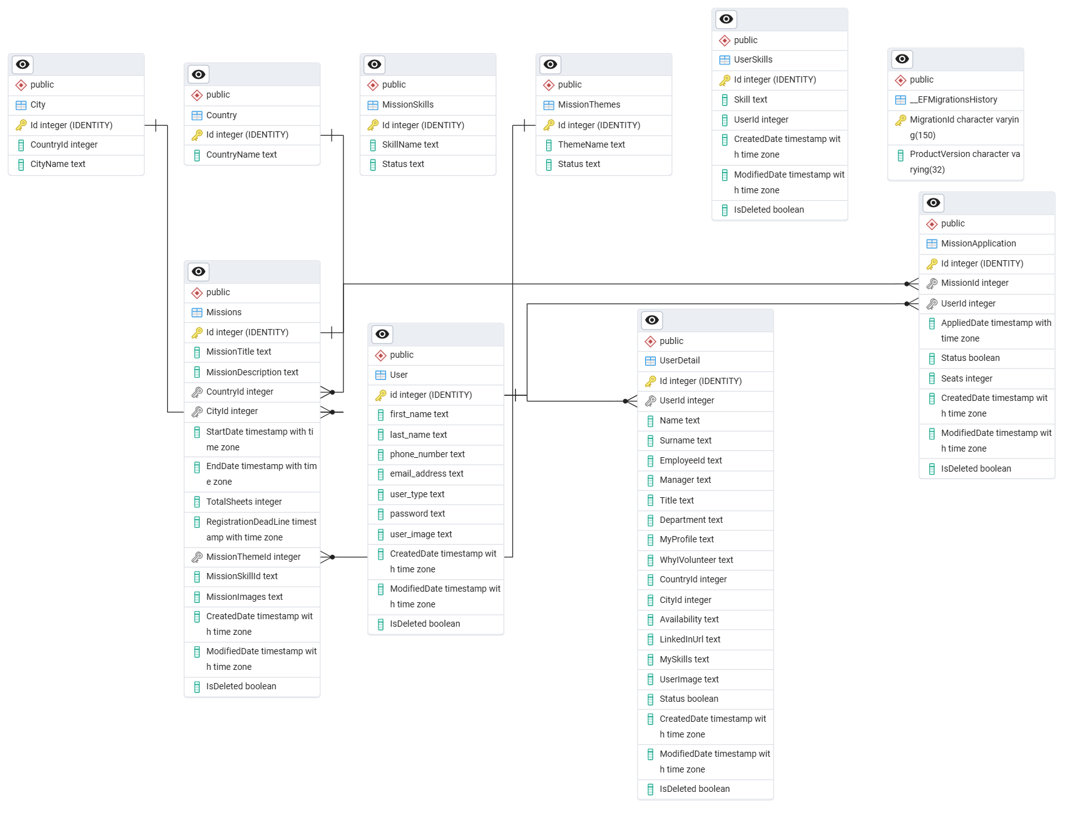
5.4 Database Schema

Chapter 6: Results & Analysis

6.1 Functional Evaluation
The Virtual Community Support system was developed through a progressive 15-day internship plan, integrating PostgreSQL, Angular, and .NET Web API. The system’s core modules include user authentication, role-based authorization (Admin/User), mission management (CRUD), theme and skill tagging, user profile management, and mission application functionality.
Each implemented module was evaluated based on its functionality, data accuracy, and user experience:
- Authentication & Authorization: Implemented via .NET Web API with secure login endpoints, password validation, and JWT-based session management. Admins and Users have distinct access scopes, successfully restricting sensitive endpoints (e.g., CRUD operations) to authorized roles.
- CRUD Operations (Users, Missions, Themes, Skills): All entities support full Create, Read, Update, and Delete operations. Entity Framework Core with Code First approach streamlined schema generation. LINQ queries enabled clean and efficient data manipulation.
- Filtering, Sorting & Pagination: Integrated on both backend (via LINQ) and frontend (Angular table components), improving performance and user navigation when handling large datasets.
- Mission Application Flow: Users can view missions, apply for them, and review their application history. Admins can view applied users, ensuring two-way visibility and system transparency.
- Profile Management: Basic profile update features were added, allowing users to personalize and manage their data.

6.2 Comparative Analysis
Throughout the internship, different approaches and technologies were explored. Key comparisons include:
Feature | Early Stage (Manual/Raw) | Final Stage (Framework/Optimized) | Verdict
Database Operations | Raw SQL queries | Entity Framework + LINQ | EF with LINQ improved productivity, reduced boilerplate
Routing & Component Handling | Basic Angular routing | Nested components with service integration | Final structure ensured better code reuse and modularity
Authentication Logic | Static validation | JWT-based secure tokens | JWT approach enabled scalable, secure session handling
Role Management | None | Fully implemented (Admin/User ACLs) | Essential for controlling access to critical features
API Testing | Postman only | Swagger + Postman | Swagger documentation boosted clarity & testing speed
UI Feedback | Console logs | Angular form validation & error messages | Improved user experience and input correctness

This evolution in architecture and methodology reflected a clear learning curve and real-world software development adoption.

6.3 System Performance Observations
- API Response Time: Average response time was within 200–300ms for CRUD operations over local development. Optimization via indexed PostgreSQL tables and asynchronous API methods improved responsiveness.
- Frontend Performance: Angular’s reactive rendering ensured smooth transitions, even with nested components and multi-tab data views.
- Scalability Consideration: Though built as a basic MVP, the modular structure and layered backend (Controllers → Services → Repository → DB) lays a solid foundation for scaling in the future.
- Security Practices: Role-based authorization and token expiration logic reduce risks of unauthorized access. However, OAuth and password encryption improvements can be considered for production environments.

6.4 Limitations & Areas for Improvement
While the project met most internship objectives, several areas were identified for future enhancements:
- No Image/File Upload Support: User profile images or mission-related documents could not be uploaded.
- No Real-Time Feedback: Lack of WebSocket integration or refresh triggers meant users had to reload pages to see updates (e.g., mission status or new applications).
- Simplistic UI/UX: The frontend was functional but minimal. Styling, responsiveness, and accessibility features were not the focus during training.
- Limited Validation Rules: Backend and frontend validations were basic; robust error handling and form constraints would enhance reliability.

6.5 Real-World Relevance
The project provides a practical demonstration of how modern full-stack applications are built using popular frameworks and best practices. It simulates a real-world platform where NGOs or social organizations could post missions and users could volunteer — showcasing both administrative control and user engagement through a secure and maintainable system.

6.6 Screenshots
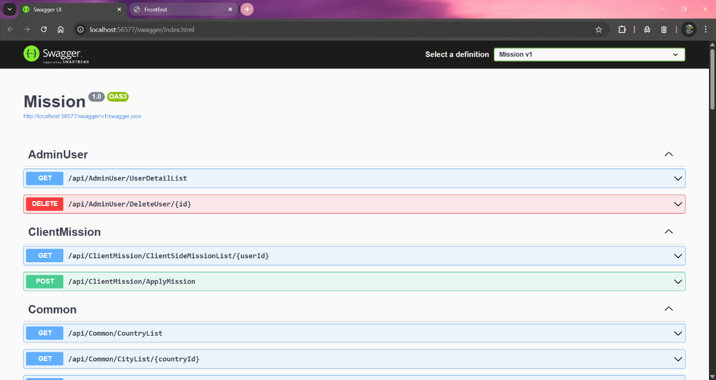
Fig 6.6.1 Swagger Backend

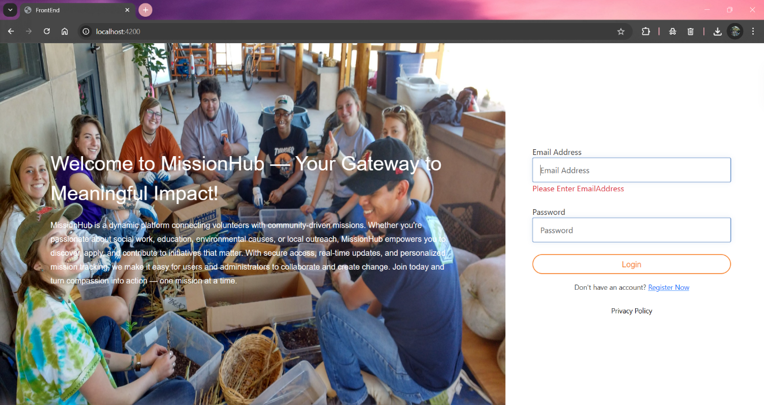
Fig 6.6.2 Frontend

Chapter 7: Conclusion & Future Work

7.1 Summary of Achievements
The Virtual Community Support project successfully delivered a functional, secure, and modular web-based platform to facilitate mission-based volunteering activities. Built using PostgreSQL, .NET Web API, and Angular, the system encapsulates key features like user management, mission applications, and role-based authorization — all developed through a structured 15-day internship training plan.
Technical Implementation: The backend was developed using .NET with the Entity Framework Code First approach. All major entities — Users, Missions, Themes, and Skills — support full CRUD operations, with secure access managed through JWT authentication and role-based authorization for Admin and User roles. The layered architecture and use of LINQ ensured maintainability and clean code practices.
Frontend Development: Angular was used to build a responsive and modular frontend, enabling users to interact with forms, view mission listings, manage their profiles, and perform CRUD operations where authorized. Angular services and routing provided a smooth and dynamic single-page experience.
Authentication & Authorization: Secure login with JWT tokens and strict role-based access control ensured system integrity and protection of admin functionalities. Unauthorized actions are appropriately blocked and user sessions managed efficiently.
Data Management & Integrity: The use of PostgreSQL as the database ensured reliable data storage, and schema design was aligned with relational integrity principles. LINQ queries allowed for efficient data handling, including sorting, filtering, pagination, and joins.
Mission Application Flow: Users can browse missions and apply for them through a clean workflow. Admins can track user applications, aligning with the core purpose of building a virtual community support system.
Deployment Readiness: Initial deployment strategies and AWS service concepts were covered on the final day of the internship, ensuring the system is prepared for cloud deployment and scaling.

7.2 Future Enhancements
Though the current system fulfils the basic requirements of a volunteering platform, several improvements and extensions can make it more robust, user-friendly, and production-ready.
1. UI/UX Enhancements:
- Improve UI design using frameworks like Bootstrap or Angular Material.
- Add animations, responsive design, and accessibility features.
- Provide a better mobile experience.
2. File Upload Functionality:
- Enable users to upload profile pictures.
- Allow mission creators (admins) to upload related documents (e.g., posters, PDFs).
3. Real-Time Features:
- Integrate WebSockets or SignalR for real-time mission updates and application status changes.
- Add real-time notifications for users when a mission is posted or accepted.
4. Advanced Search & Filtering:
- Implement multi-criteria search on missions (e.g., location, skill, date, theme).
- Add mission tags and user skill matching to recommend relevant missions.
5. Audit & Logging System:
- Implement an activity log for admins to monitor actions taken by users.
- Track mission status changes and failed login attempts.
6. Mobile Application Integration:
- Develop a cross-platform mobile app using Flutter or React Native.
- Sync it with the existing backend to increase accessibility for volunteers.
7. External Communication Features:
- Integrate basic chat or message features between volunteers and mission creators.
- Allow notifications via email or SMS for mission status updates.
8. Deployment & Scalability:
- Complete cloud deployment using AWS (e.g., EC2, RDS, S3).
- Integrate CI/CD pipelines for faster and safer updates.

7.3 Technical Contributions
This internship project provided practical experience in building a scalable full-stack web application while adhering to industry-standard development practices. Major technical contributions include:
- End-to-End Development Workflow: Covering everything from backend database schema creation (PostgreSQL) to frontend development (Angular) and secure API development (.NET).
- Authentication & Authorization: Demonstrated implementation of JWT-based auth and role-based access control, essential for multi-user systems.
- Modular, Scalable Architecture: Developed using a clean N-tier structure separating concerns across controller, service, and repository layers — making the codebase maintainable and extensible.
- Entity Framework & LINQ: Leveraged EF Core’s Code First approach and LINQ for clean, readable data access logic.
- Practical Understanding of REST APIs: Built and tested multiple endpoints with Swagger and Postman, simulating a professional API-first development environment.
- Cloud Readiness & CI/CD Understanding: Gained initial exposure to AWS and deployment strategies, preparing the system for future production-level deployment.
- Team-Ready Development Skills: By following best practices in code structuring, endpoint naming, and modularity, the project establishes a strong foundation for collaborative team development in the future.

References
- Microsoft. .NET Documentation. https://learn.microsoft.com/en-us/dotnet/
- Microsoft. ASP.NET Core Web API Documentation. https://learn.microsoft.com/en-us/aspnet/core/web-api
- Microsoft. Entity Framework Core Documentation. https://learn.microsoft.com/en-us/ef/core/
- Angular Team. Angular Documentation. https://angular.io/docs
- PostgreSQL Global Development Group. PostgreSQL Documentation. https://www.postgresql.org/docs/
- JWT.io. Introduction to JSON Web Tokens. https://jwt.io/introduction
- Swagger. Swagger OpenAPI Tools. https://swagger.io/tools/swagger-ui/
- AWS. Amazon Web Services Documentation. https://docs.aws.amazon.com/
- W3Schools. HTML, CSS, JavaScript Reference Guides. https://www.w3schools.com/
- Stack Overflow. Community Q&A for Web Developers. https://stackoverflow.com/

